**Name: Mohammed Zeeshan Bage Email: Zeeshanbge@gmai.com**

**Address: Karanja Road Beed. Contact Number: 8888924956**

**(System Engineer)**

### CAREER OBJECTIVE:

To work in a Competitive Company operating in a challenging scenario which will provide me an excellent opportunity to learn and grow along with the company.

**Technical Skills:**

* **Microsoft (Dot Net):**
* Good Knowledge of C#, Strong object-oriented programming skills, Windows form Desktop application, ASP.NET core, ASP.NET MVC, entity framework core.
* Experience in coding, developing module using C#, ASP.NET and Windows Form application with DevExpress.
* Exposure to Azure DevOps and Azure portal.
* Experience in Visual Studio 2019 and source control (Git).
* Experience in Bug fixing and Debugging the WinForm .NET application.
* Experience in Publishing/Deploying WinForm .NET application using ClickOnce deployment.
* Publishing .Net core web API service app on Azure.
* Knowledge of WCF, SQL Server, SOAP, Rest.
* Knowledge on client-side technologies: HTML, TypeScript, Angular 6, Bootstrap
* Experience in Xamarin for building Android and iOS apps with .NET and C#
* **MS SQL:**
* Experience in Microsoft SQL Server database
* Experience in Creating SSIS Packages for Exporting data load from SQL database to CSV.
* Experience in creating/altering different tables, views, stored procedures and Functions In SSMS 2018.

**Education:**

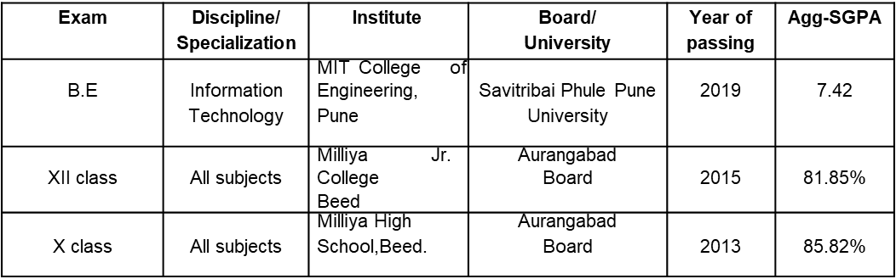

**Technical Proficiencies:**

* **Programming Languages :-** Python, C#.
* **Database :-** MS SQL, SOQL and SOSL.
* **Technologies :**- ASP.Net, MVC 2.0,WPF , LINQ , Win-forms.
* **Operating System :-**  Windows
* **IDE’s :-** Eclipse, Visual Studio, SSMS

**Work Experience**

**Infosys, Pune**

**Designation: System Engineer (Sept 2019)**

Project Synopsis:

Maintenance and enhancement of 13+ .Net applications. This project is a complete IT solution to install and maintain elevators, escalators, Autowalks, and automatic doors business. There are different applications for managing and running the business (Tracking, recording, safety services, Payroll etc). Windows desktop and web application for admins, managers, and supervisors. Android and iOS application for Mechanic, technicians, and supervisors.

Tools and Technologies Used: VS2019, C#, ASP.Net, WinForm Dev Express, Code smith, MS-SQL Server 2015.

Roles and Responsibilities:

1. Enhancement and maintenance of all the application.
2. Bug fixing, change requests, problem management and new enhancements.
3. Involved in coding, developing modules.
4. Involved in writing stored procedures, updating table schema, DB design etc.
5. Deployment and publishing web API, WPF services, Desktop application and Mobile applications.

Strengths:

1. Analyzing and Problem-solving skills.
2. Ability to adapt quickly to the changes in the working environment.
3. Flexible to time demand, Quick learner.
4. Working in a Team.

**Infosys internal certifications**

* Infosys certified Csharp programmer.
* Infosys certified MySQL associate.
* Infosys certified Open Chain Practitioner
* Infosys Global Agile Developer certification.
* Infosys certified Salesforce Administrator.